Name:_____________________________ /53

11 HUMAN BIOLOGY

**REPRODUCTION AND HORMONAL CONTROL TEST**

Part one – multiple choice

1. The seminiferous tubules are long and convoluted to:

a) increase the area available for sperm storage

b) increase surface area to volume ratio to allow for efficient diffusion

c) fit into a smaller space

d) allow for a greater number of spermatogonium

2. What is the function of cilia in the fallopian tube?

a) To provide nutrients for the ova.

b) To produce ova.

c) To lubricate the fallopian tube.

d) To guide ova along the fallopian tube.

3. Day 1 of the menstrual cycle is:

a) ovulation

b) beginning of menstruation

c) when the new follicle begins to develop

d) none of the above

4. What is the function of the testes?

a) Produces testosterone and spermatozoa.

b) Makes sperm and oestrogen.

c) Allows sperm to mature before moving into the vas deferens.

d) Produces luteinising hormone and testosterone.

5. Which of the following is **not** true?

a) The male gamete is spermatozoa.

b) The female gonad is the ovary.

c) Gametes are diploid.

d) Gametes are sex cells.

6. Menarche is the

a) end of the fertile period in women

b) onset of puberty in girls

c) onset of menstruation in girls

d) rapid growth at puberty

7 Which of the following hormones causes development of secondary sexual characteristics in males?

a) follicle stimulating hormone

b) oestrogen

c) testosterone

d) luteinizing hormone

8. The ovarian follicle secretes the hormone:

a) oestrogen

b) follicle stimulating hormone

c) progesterone

d) luteinizing hormone

9. The following are events leading to menstruation. Which is the PRIMARY event which sets the others in motion?

a) degeneration of the blood supply to the endometrium

b) degeneration or the corpus luteum

c) reduction in the blood concentrations or oestrogen and progesterone

d) reduction in the supply of Luteinising Hormone

10. Menopause is the

a) end of the fertile period in women

b) onset of puberty in girls

c) onset of menstruation in girls

d) rapid growth at puberty

11. Where does insemination occur?

a) Anywhere

b) Fallopian tube (oviduct)

c) Ovary

d) Vagina

12. Where would you find the corona radiata?

a) In the tail of a spermatazoa

b) Surrounding the mature ovum

c) Protecting the ovary

d) none of the above

13. Females are born with primary oocytes. Which of the following is **INCORRECT** about those oocytes?

a) They are in Prophase II

b) There are several hundred thousand of them

c) They are diploid

d) They are surrounded by a layer forming a primary follicle

Part two – short answer

1. What secondary sexual characteristics would a physically mature adolescent show?

List 3 for males and 3 for females. (3 marks)

|  |  |
| --- | --- |
| Males | Females |
|  |  |

1. Compare spermatogenesis and oogenesis, listing similarities and differences. (4 marks)

_______________________________________________________________________________________________________________________________________________________________________________________________________________________________________________________________________________________________________________________________________________________________________________________________________________________________________________________________________________________________________________________________________________________________________________________________________________________________________________________________________________________________________________________________________________________________________________________________________________________________________________________________________________________________________________________________________________________________________________________________________________________________________________________________________________________________________________________________________________________________________________________________________________________________________________________________________________________

3. Explain two differences between mitosis and meiosis. (2 marks)

_____________________________________________________________________________________________________________________________________________________________________________________________________________________________________________________________________________________________________________________________________________________________________________________________________________________________________________________________________________________________________________________________________________________________________________________________________________________________________________________________________________________________________________________________________________________________________________________________________________________

4. a. On the diagram below locate the following: Fimbrae, cervix, endometrium, uterus, vagina and fallopian tube.

b. Show on the diagram where the following processes would occur: fertilisation, implantation, ovulation (6 marks)

[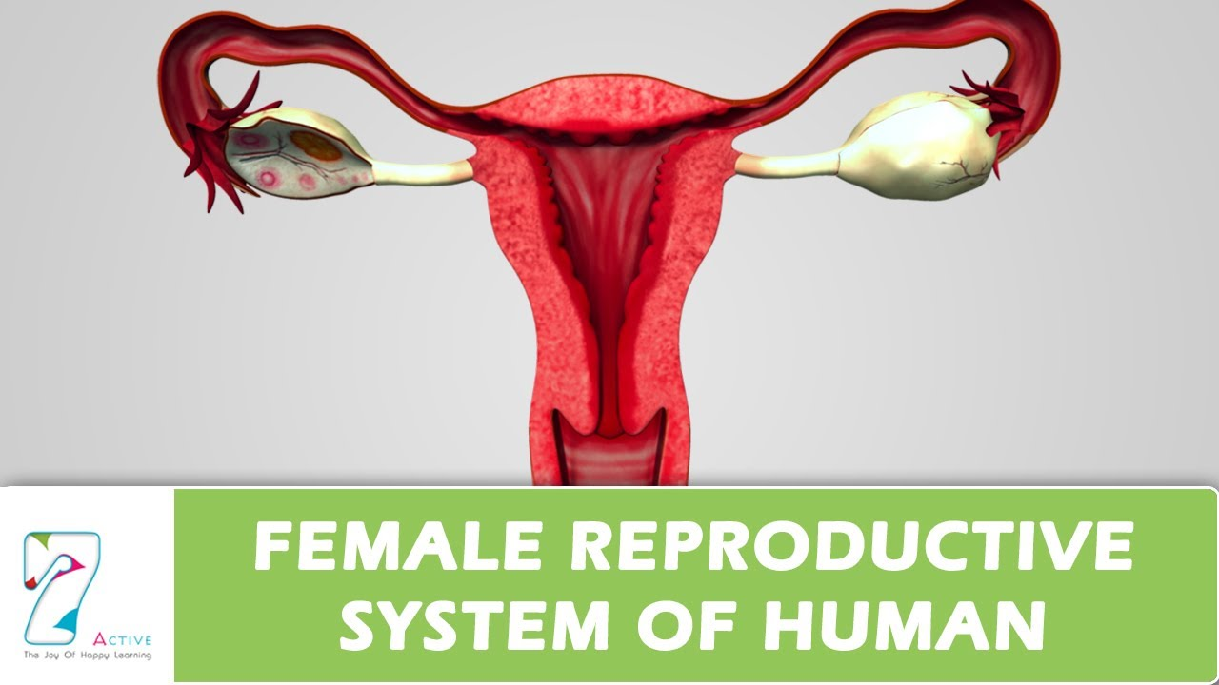](http://www.google.com.au/url?sa=i&rct=j&q=female%20reproductive%20system%20diagram&source=images&cd=&cad=rja&uact=8&docid=yMLneVZGoKrYVM&tbnid=iLSZsC6yAGI-1M:&ved=0CAUQjRw&url=http://www.youtube.com/watch?v%3Da8fgm-zEYjQ&ei=-OTVU6jsOMf28QXi_4DADA&psig=AFQjCNF1qA94OgrLrb2tgnBfwC2S765RFA&ust=1406612678279837)

5. a. On the diagram below locate and label the three glands involved in the production of semen.

b. This diagram does not show the seminiferous tubules. **Draw** them in.

c. Locate and label the tissue affected during an erection (5 marks)

[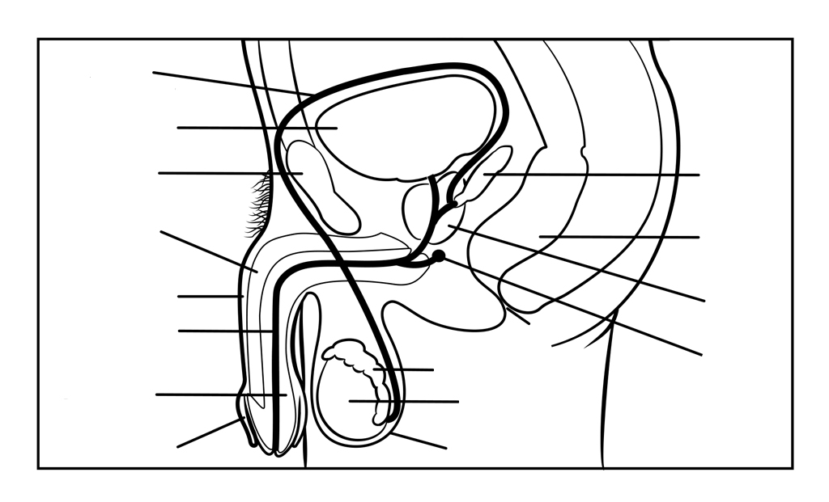](http://www.google.com.au/url?sa=i&rct=j&q=male+reproductive+system+diagram&source=images&cd=&cad=rja&uact=8&docid=l31ufFQfoQ0NEM&tbnid=bLrFxXmcw8QSJM:&ved=0CAUQjRw&url=http://gdhr.wa.gov.au/resources/illustrations&ei=OefVU5b_JY7q8AWB7oKIAg&psig=AFQjCNGZDAvArcOZbLhsYMVI187TReI50g&ust=1406613260776187)

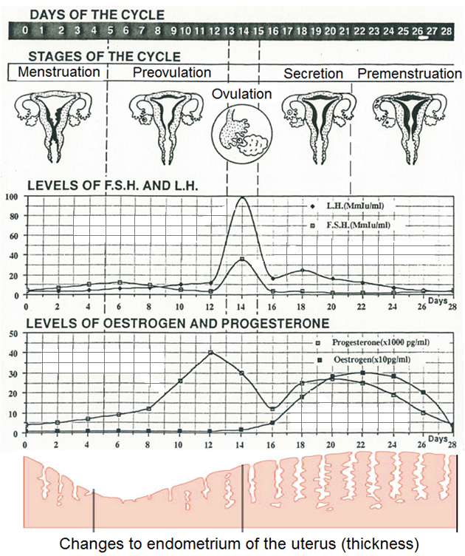Use the diagram below to answer the following questions.

6. Why does L.H peak when it does? (1 mark)

__________________________________________________________________________________________________________________________________________________________________________________________________________________________________

7. A Locate the corpus luteum on the diagram above. (1 mark)

B What is the function of the corpus luteum? (1 mark)

__________________________________________________________________________________________________________________________________________________________________________________________________________________________________

8. Why is the secretion phase of the menstrual cycle called the secretion phase? (1 mark)

__________________________________________________________________________________________________________________________________________________________________________________________________________________________________

9. Fill in the table below. (6 marks)

|  |  |  |  |
| --- | --- | --- | --- |
|  | Where is it secreted from | Target organ | Effect of hormone |
| FSH |  |  | **⮚**  **⮚** |
| HCG |  |  | **⮚** |

Part two – extended answer

10. There are a number of steps involved in the production of semen. Starting from the end of spermatogenesis, **describe** the steps taken to produce the final ejaculated product. Include the substances added, where they are added from and what their functions are.

(10 marks)

__________________________________________________________________________________________________________________________________________________________________________________________________________________________________________________________________________________________________________________________________________________________________________________________________________________________________________________________________________________________________________________________________________________________________________________________________________________________________________________________________________________________________________________________________________________________________________________________________________________________________________________________________________________________________________________________________________________________________________________________________________________________________________________________________________________________________________________________________________________________________________________________________________________________________________________________________________________________________________________________________________________________________________________________________________________________________________________________________________________________________________________________________________________________________________________________________________________________________________________________________________________________________________________________________________________________________________________________________________________________________________________________________________________________________________________________________________________________________________________________________________________________________________________________________________________________________________________________________________________________________________________________________________________________________________________________________________________________________________________________________________________________________________________________________________________________________________________________________________________________________________________________________________________________________________________________________________________________________________________________________________________________________________________________________________________________________________________________________________________________________________________________________________________________________________________________________________________________________________________________________________________________________________________________________________________________________________________________________________________________________________________________________________________________________________________________________________________________________________________________________________________________________________________________________________________________________________________________________________________________________________________________________________________________________________________________________________________________________________________________________________________________________________________________________________________________________________________________________________________________________________________________________________________________________________________________________________________________________________________________________________________________________________________________________________________________________________________________________________________________________________________________________________________________________

Name:_____________________________ /53

2A2B HUMAN BIOLOGY

**CELL DIVISION, REPRODUCTION AND HORMONAL CONTROL TEST**

Part one – multiple choice

1. The seminiferous tubules are long and convoluted to:

a) increase the area available for sperm storage

b) increase surface area to volume ratio to allow for efficient diffusion

c) fit into a smaller space

d) allow for a greater number of spermatogonium

2. What is the function of cilia in the fallopian tube?

a) To provide nutrients for the ova.

b) To produce ova.

c) To lubricate the fallopian tube.

d) To guide ova along the fallopian tube.

3. Day 1 of the menstrual cycle is:

a) ovulation

b) beginning of menstruation

c) when the new follicle begins to develop

d) none of the above

4. What is the function of the testes?

a) Produces testosterone and spermatozoa.

b) Makes sperm and oestrogen.

c) Allows sperm to mature before moving into the vas deferens.

d) Produces luteinising hormone and testosterone.

5. Which of the following is **not** true?

a) The male gamete is spermatozoa.

b) The female gonad is the ovary.

c) Gametes are diploid.

d) Gametes are sex cells.

6. Menarche is the

a) end of the fertile period in women

b) onset of puberty in girls

c) onset of menstruation in girls

d) rapid growth at puberty

7 Which of the following hormones causes development of secondary sexual characteristics in males?

a) follicle stimulating hormone

b) oestrogen

c) testosterone

d) luteinizing hormone

8. The ovarian follicle secretes the hormone:

a) oestrogen

b) follicle stimulating hormone

c) progesterone

d) luteinizing hormone

9. The following are events leading to menstruation. Which is the PRIMARY event which sets the others in motion?

a) degeneration of the blood supply to the endometrium

b) degeneration or the corpus luteum

c) reduction in the blood concentrations or oestrogen and progesterone

d) reduction in the supply of Luteinising Hormone

10. Menopause is the

a) end of the fertile period in women

b) onset of puberty in girls

c) onset of menstruation in girls

d) rapid growth at puberty

11. Where does insemination occur?

a) Anywhere

b) Fallopian tube (oviduct)

c) Ovary

d) Vagina

12. Where would you find the corona radiata?

a) In the tail of a spermatazoa

b) Surrounding the mature ovum

c) Protecting the ovary

d) none of the above

13. Females are born with primary oocytes. Which of the following is **INCORRECT** about those oocytes?

a) They are in Prophase II

b) There are several hundred thousand of them

c) They are diploid

d) They are surrounded by a layer forming a primary follicle

Part two – short answer

1. What secondary sexual characteristics would a physically mature adolescent show?

List 3 for males and 3 for females. (3 marks)

|  |  |
| --- | --- |
| Males | Females |
| Enlargement of Penis, scrotum, prostate  Growth of pubic, facial, underarm, chest hair  Shoulders broaden  Deeper voice – enlarged larynx  Increased perspiration  Oil production | Breasts  Hips widening  Deposition of fat leading to curved shape  Growth of pubic, underarm hair  Oil production |

1. Compare spermatogenesis and oogenesis, listing similarities and differences. (4 marks)

|  |  |
| --- | --- |
| Spermatogenesis | Oogenesis |
| * 4 gametes * Begins at puberty * Leaves behind one cell to undergo the process again * Occurs in males | * 1 gamete * Begins before birth then pauses at prophase * Does not leave behind another cell to produce new cells * Occurs in females |

3. Explain two differences between mitosis and meiosis. (2 marks)

Any 2 but must be explained to get the mark

4. a. On the diagram below locate the following: Fimbrae, cervix, endometrium, uterus, vagina and fallopian tube. (1/2mark each)

b. Show on the diagram where the following processes would occur: fertilisation, implantation, ovulation (1 mark each) (6 marks)

[](http://www.google.com.au/url?sa=i&rct=j&q=female%20reproductive%20system%20diagram&source=images&cd=&cad=rja&uact=8&docid=yMLneVZGoKrYVM&tbnid=iLSZsC6yAGI-1M:&ved=0CAUQjRw&url=http://www.youtube.com/watch?v%3Da8fgm-zEYjQ&ei=-OTVU6jsOMf28QXi_4DADA&psig=AFQjCNF1qA94OgrLrb2tgnBfwC2S765RFA&ust=1406612678279837)

5. a. On the diagram below locate and label the three glands involved in the production of semen. 1 mark each

b. This diagram does not show the seminiferous tubules. **Draw** them in. 1

c. Locate and label the tissue affected during an erection 1 (5 marks)

[](http://www.google.com.au/url?sa=i&rct=j&q=male+reproductive+system+diagram&source=images&cd=&cad=rja&uact=8&docid=l31ufFQfoQ0NEM&tbnid=bLrFxXmcw8QSJM:&ved=0CAUQjRw&url=http://gdhr.wa.gov.au/resources/illustrations&ei=OefVU5b_JY7q8AWB7oKIAg&psig=AFQjCNGZDAvArcOZbLhsYMVI187TReI50g&ust=1406613260776187)

Use the diagram below to answer the following questions.

7. Why does L.H peak when it does? (1 mark)

Released by the pituitary to promote Ovulation and formation of Corpus Luteum

Must mention both Ovulation and CL for mark

8. A Locate the corpus luteum on the diagram above. (1 mark)

B What is the function of the corpus luteum? (1 mark)

Produce progesterone and oestrogen and delay menstruation

9. Why is the secretion phase called the secretion phase? (1 mark)

As watery mucus is secreted by endometrium, cervix and fallopian tubes.

10. Fill in the table below. (6 marks)

|  |  |  |  |
| --- | --- | --- | --- |
|  | Where is it secreted from | Target organ | Effect of hormone |
| FSH | Pituitary Gland  (brain is not good enough)  1 | Seminiferous tubules and follicles of ovaries  Must mention both for mark  1 | ⮚production of sperm  ⮚maturation of ovarian follicles  Must mention both for mark  1 |
| HCG | Placenta  1 | Corpus luteum  1 | ⮚Maintenance of corpus luteum during early stages of pregnancy  1 |

Part two – extended answer

1. There are a number of steps involved in the production of semen. Starting from the beginning of the end of spermatogenesis, **describe** the steps taken to produce the final ejaculated product. Include the substances added, where they are added from and what their functions are.

(10 marks)

Sperm is produces in testes and stored in epididymis

Matures in epididymis

Seminal vesicle secretes fluid

Which is rich in sugars

to give nutrients to sperm

Prostate gland

Secretes thin milky alkaline fluid

to activate sperm/ combat acidic vagina

Bulbo urethral gland

clear mucus that

acts as lubricant

1 mark each point

-1 for any in the incorrect order